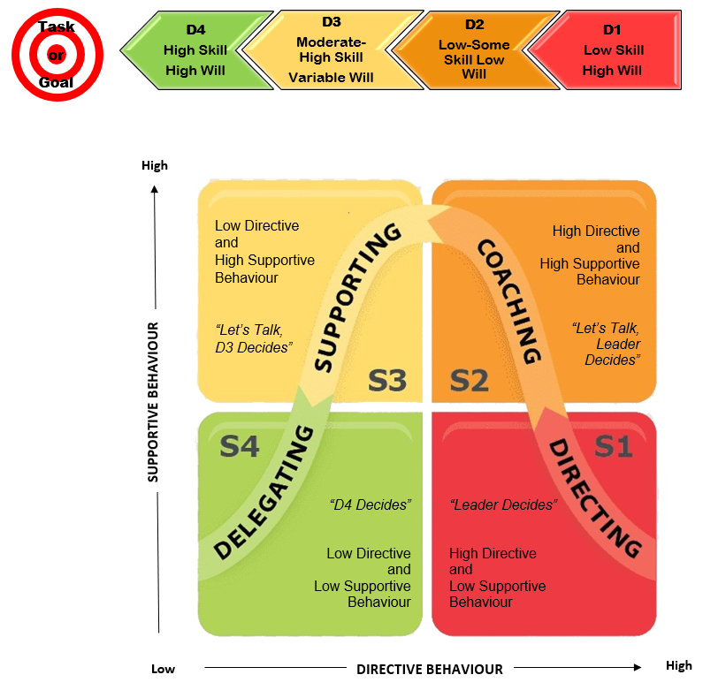

Ken Blanchard, 2009

Situational Leadership Model



| YOUR Focus Areas | Style YOU need from your leader |
| --- | --- |
| Curriculum |  |
| Leading change |  |
| Parent liaison |  |
| Behaviour management |  |
| Organisation |  |
| Communication |  |

Steve Francis steve@stevefrancis.NET.au Ph 0421 705 693

| Teachers You Lead | Focus Area | Leadership style needed |
| --- | --- | --- |
|  | Effectively manage a class |  |
| Differentiate to suit learning needs |  |
| Utilise IT to engage students |  |
| Build rapport and trust with parents |  |
| Implement change |  |
|  | Effectively manage a class |  |
| Differentiate to suit learning needs |  |
| Utilise IT to engage students |  |
| Build rapport and trust with parents |  |
| Implement change |  |
|  | Effectively manage a class |  |
| Differentiate to suit learning needs |  |
| Utilise IT to engage students |  |
| Build rapport and trust with parents |  |
| Implement change |  |